### **Hippity Hop...The Easter Bunny is Coming Your Way on a Carousel**

Hippity Hop, make way for the Easter bunny! He is coming your way on a carousel. He really spins in circles because this carousel has an axle built inside. It's a perfect design for Easter. You can fill the box with jellybeans and give it as a present.

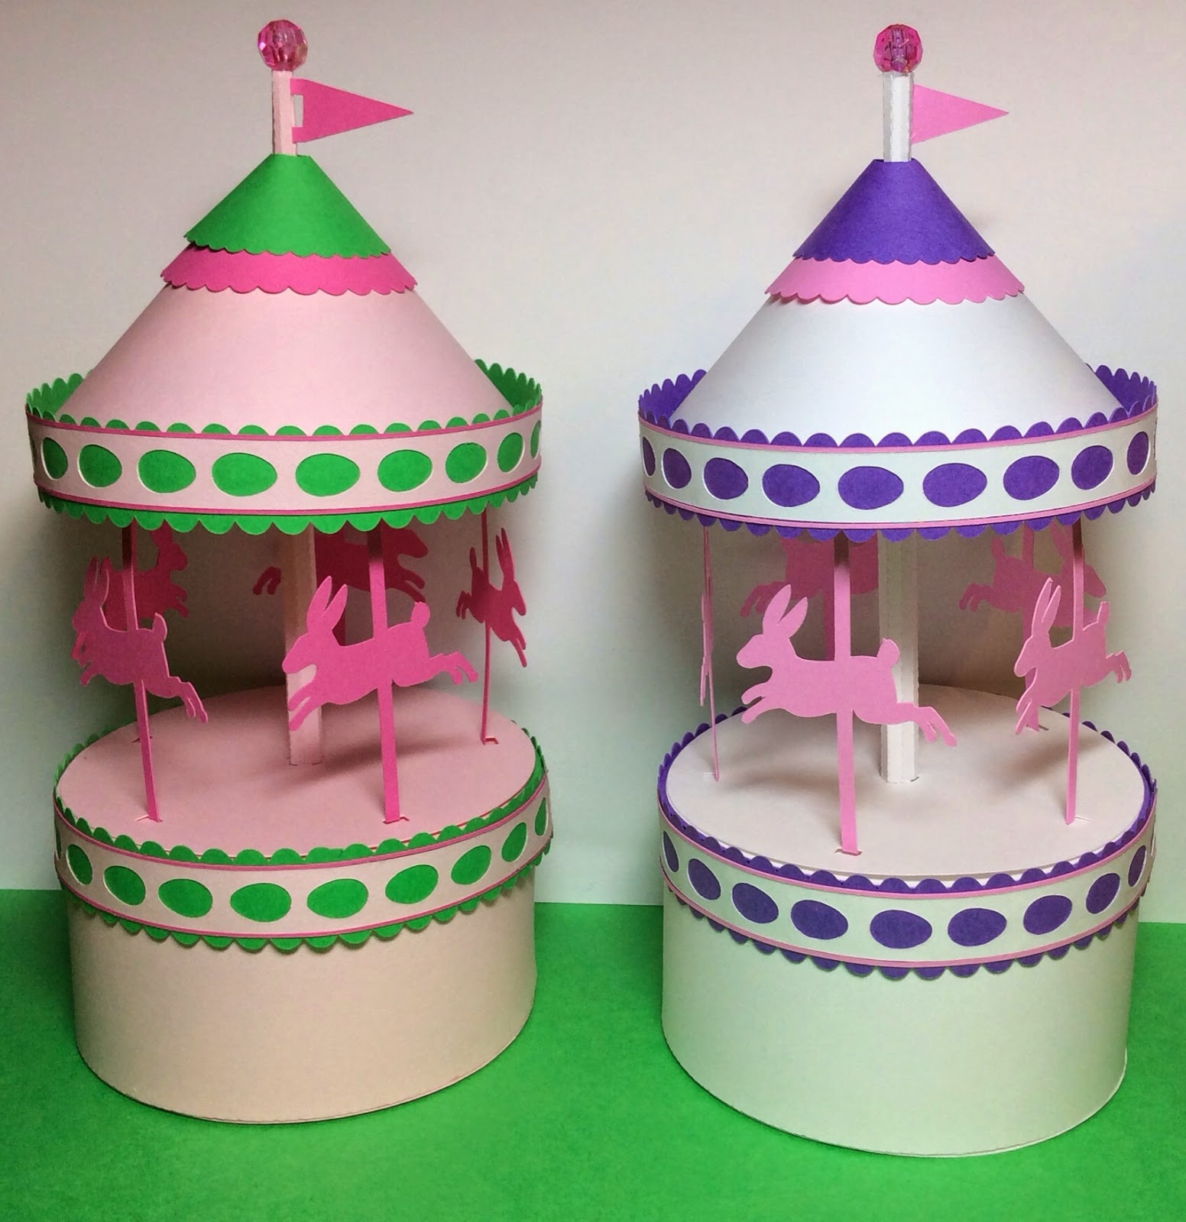

Easter Bunny Carousel

Use the directions from a previous post to assemble this pretty carousel.

<http://papercraftetc.blogspot.com/2014/02/a-carousel-box-that-really-spins.html>